
Developing Applications for GTViewer

Using Visual Studio .NET 2005 and 2008



© Copyright 2008 Graphic Technologies, Inc. All Rights Reserved.
Portions of this computer program are copyright © 2008 Srego, Inc. All Rights Reserved.

Contents

Introduction 3
Creating an External Application for GTViewer with Visual Studio .NET 2005 4
Creating an External Application for GTViewer with Visual Studio .NET 2008 15
Highlight by Phase Example Application in VB.NET 26
Moving from Visual Basic 6 to Visual Basic .NET 34
External Application Template Code in C# 36
Highlight by Phase Application in C# 37

Introduction

Almost from its beginning, GTViewer has been extendible with External Applications. These External Applications can be for tracing, data collection, importing data, data monitors, etc. GTViewer has been supporting External Applications though a technique called Dependency Injection. An External Application is written as a COM object with an interface to GTViewer; then entries in the .GTM File define the COM objects that can be used with the dataset. GTViewer dynamically adds the External Applications to its menus when the dataset is opened and will launch the External Applications when they are selected. The External Applications are run inside of GTViewer and appear seamlessly integrated.
In the past, almost all GTViewer External Applications were written in Visual Basic 6 (VB6). There were a few written in Visual C++ and even some written in Excel (VBA), but the majority were in VB6. Not only is VB6 getting a little long in the tooth (released in 1998), but Visual Basic .NET and the .NET Framework have finally gained acceptance as a development platform and the .NET savvy development crowd is rapidly growing.
Strangely enough, GTViewer has been able to support .NET External Applications all along, and GTI had even provided a template .NET application several years ago. However, until Microsoft ended its support for VB6 in March 2008, the idea of using .NET for the development of External Applications had gained little traction.
With GTViewer 8.0, even better support for developing .NET External Application has been added along with new templates and examples. This document covers several topics:
- Creating an External Application for GTViewer in Visual Studio .Net 2005 and 2008
- Template External Applications for GTViewer in VB.Net and C#
- The complete Highlight by Phase sample application in VB.NET and C#

Creating an External Application for GTViewer with Visual Studio .NET 2005

- Create a new project in Visual Studio. The project type can be either Visual Basic or C#. This example will be Visual Basic .NET.
- Select the Windows Control Library from the list of templates:
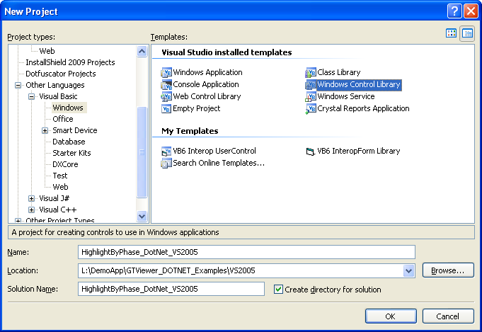

- The next step is to add GTViewer as a reference to your project so that the COM interface will be available to Intellisense and the GTViewer types will be defined. If you are using XP, this process is very simple. For Vista, the process is more complicated. Both XP and Vista instructions are provided below.
For XP
Once the Project is created, add the GTViewer.tlb as a reference. Select Project/Add Reference in Visual Studio:
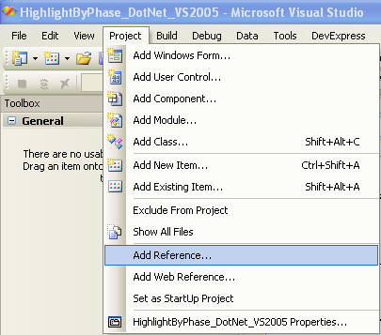
Browse to find the GTViewer.tlb file which will be located in the GTViewer product directory. This directory will be c:\Program Files\Graphic Technologies Inc\GTViewer (or something similar):
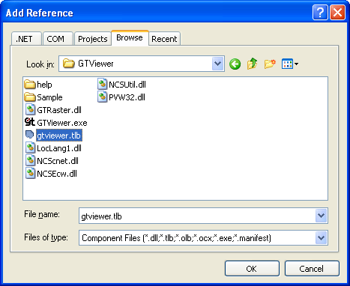
Then click OK.
For Vista
Security Issues prevent Visual Studio from automatically creating the COM wrapper dll. This problem is very likely a bug in Visual Studio working with Vista and may be resolved by Microsoft at some point in the future; however, the work around is straight forward.
With GTViewer version 8.0.0.15+, the COM Wrapper Dll is provided. It is called GTViewer.dll. Follow the XP instructions above for adding a reference, only select the GTViewer.dll instead of GTViewer.tlb.
If you are using a version of GTViewer that does not deliver the GTViewer.dll, you can create one yourself using the Tlbimp utility. You must run the Visual Studio Command Prompt (located under Programs/Visual Studio .NET 200X/Visual Studio Tools). You must run the command prompt as Administrator (right click and selected Run As Administrator). Then, in the new command prompt window, change the directory to the GTViewer product directory (c:\program files\graphic technologies inc\GTViewer). Run the tlbimp command with the following parameters:
tlbimp gtviewer.tlb /out:gtviewer.dll

- Several Project settings need to be made before creating the External Application. In Visual Studio, select Project/<Project Name> Properties , then:
- On the Application Tab, Click the Assembly Information button:
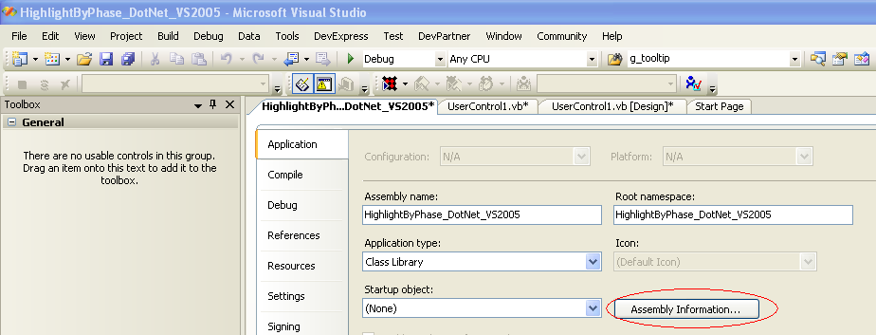

- Check the Make assembly COM-Visible box on the Assembly Information dialog:
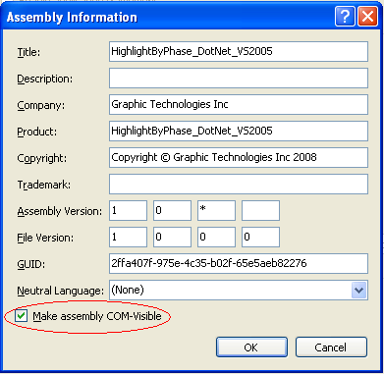
Then click OK.

- On the Compile Tab, set the Option Strict setting to On. Using Option Strict is optional; however, it is recommended especially if you plan on using Dotfuscator or simply want more design-time checks to be performed on your code.

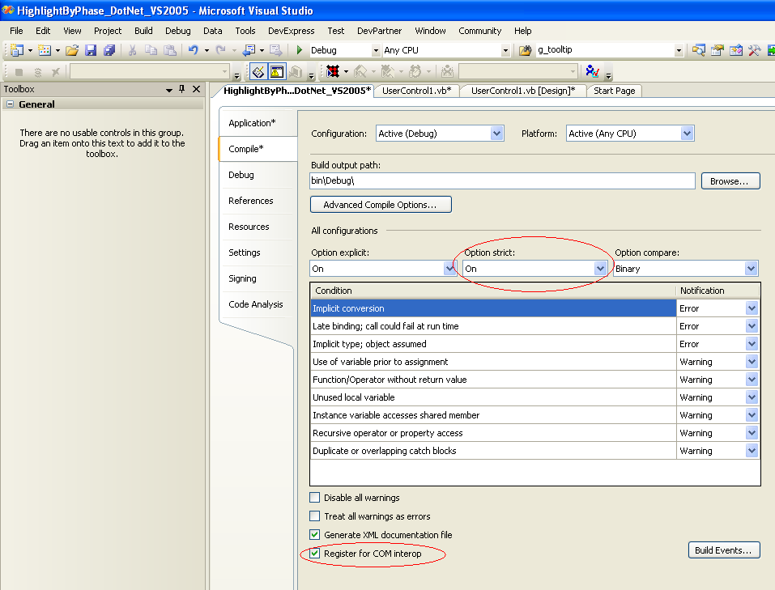
- Also on the Compile Tab, check the Register for COM interop box. If this option is not checked, you will have to manually register the application with Regasm.
- On the Debug Tab, change the Start Action to Start external program and browse to the GTViewer.exe in the GTViewer Product directory (which should be c:\program files\graphic technologies inc\gtviewer or similar):
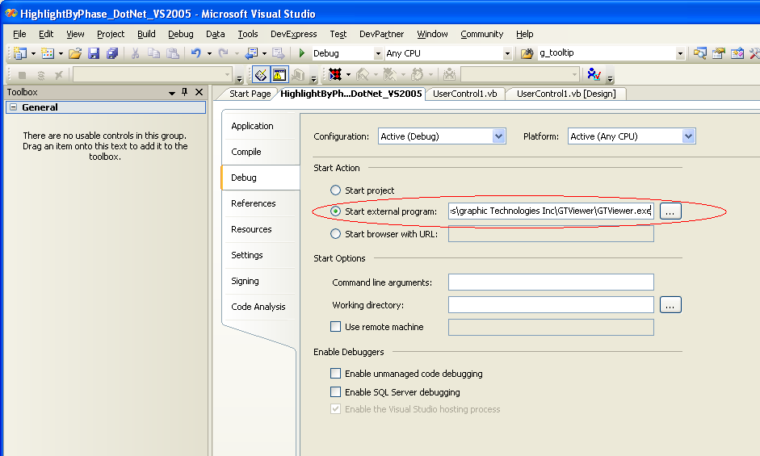

- In the Solution Explorer, right-click on the UserControl1.vb and choose View Designer:
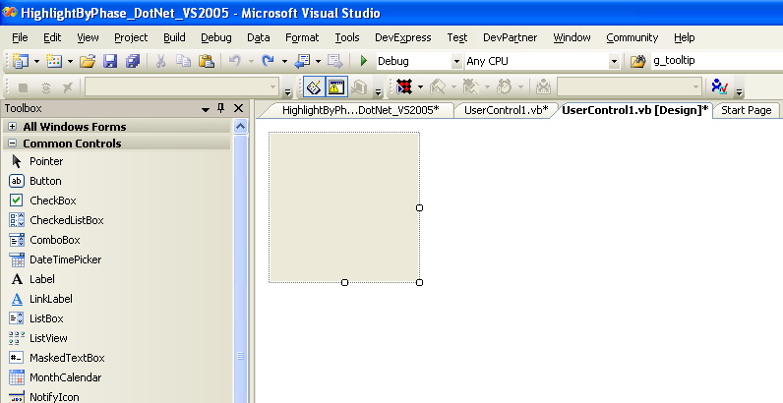
- Make the Control’s design surface larger. The size of the surface does not determine the size of the control in GTViewer.
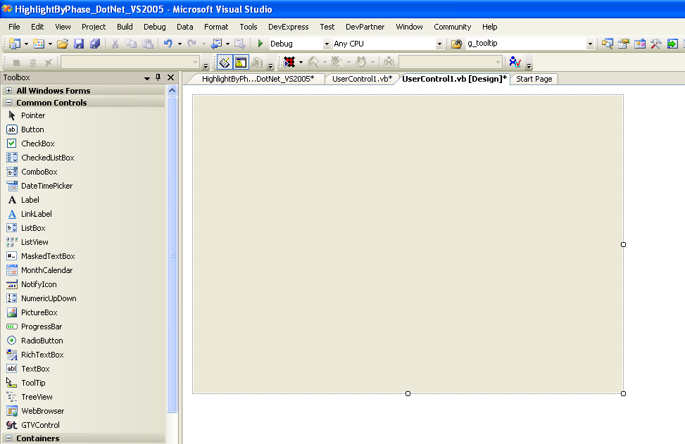

- Place a Panel control on the Control’s design surface. You will find Panel in the Toolbox under Containers. The Panel is used to size the control automatically when the External Application is displayed in GTViewer. There are many ways that this automatic sizing can be done; this simple approach is more than adequate for this example. The Panel should start at the upper left corner (0,0) and be the size that you want the application to appear in GTViewer. You will place all controls for the External Application in the panel. Make sure the panel is called Panel1 (or modify the AdjustDialogSize function in the code to match; AdjustDialogSize is discussed later).
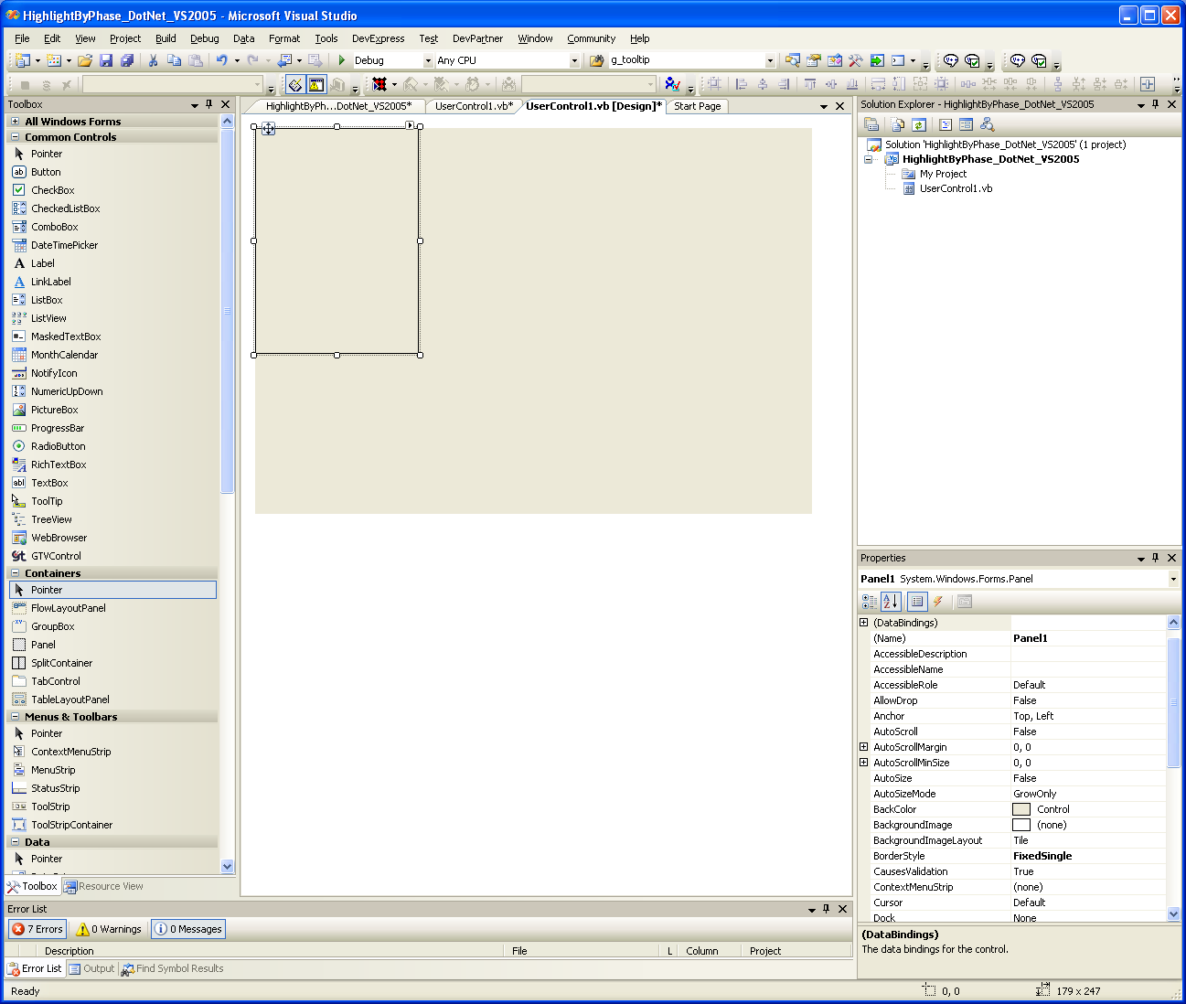
- In the Solution Explorer, right click on the UserControl1.vb file and select View Code. Then paste a copy of the following code template into the Control’s code page.
Imports System.Runtime.InteropServices

<ClassInterface(ClassInterfaceType.AutoDual)> _
Public Class UserControl1

Dim appObj As GTViewer.Application = Nothing
Dim docObj As GTViewer.Document = Nothing
Dim viewObj As GTViewer.View = Nothing
Dim dlgObj As GTViewer.DialogObject = Nothing

Public Sub SetApplicationObject(ByVal obj As Object)
appObj = CType(obj, GTViewer.Application)
End Sub

Public Sub SetDocumentObject(ByVal obj As Object)
docObj = CType(obj, GTViewer.Document)
End Sub

Public Sub SetViewObject(ByVal obj As Object)
viewObj = CType(obj, GTViewer.View)
End Sub

Public Sub SetDialogObject(ByVal obj As Object)
dlgObj = CType(obj, GTViewer.DialogObject)
End Sub

Public Sub EventMessage(ByVal messageType As Long, ByVal value1 As Long, _
ByVal value2 As Long, ByVal value3 As Long, _
ByVal value4 As Long)

Select Case messageType
Case 0
' Initialization Code here
dlgObj.SetTitle("App Name")
AdjustDialogSize()

Case 1
' Termination Code here

End Select

End Sub

Private Sub AdjustDialogSize()

Panel1.BorderStyle = Windows.Forms.BorderStyle.None

dlgObj.SetSizeEx(Panel1.Width + Panel1.Left + 6, _
Panel1.Height + Panel1.Top + 38, 0)

End Sub

End Class

The code shown above is the minimum code required to use an External Application with GTViewer. The template code is similar to the Visual Basic 6 External Application template code, but there are some differences. A detailed description of the code follows:
- The InteropServices assembly must be imported. Make sure the following line is at the top of the file:
Imports System.Runtime.InteropServices

You may have other assemblies to import, but this one is required.
- You must specify the Class Interface type for the User Control:
<ClassInterface(ClassInterfaceType.AutoDual)> _
Public Class UserControl1
.
.
.
End Class

If the Class Interface type is not specified like it is shown above, GTViewer will not see the User Control.
- Define global variables for the GTViewer interface objects:
Dim appObj As GTViewer.Application = Nothing
Dim docObj As GTViewer.Document = Nothing
Dim viewObj As GTViewer.View = Nothing
Dim dlgObj As GTViewer.DialogObject = Nothing

If the GTViewer.tlb file has not been set as a Project Reference, the GTViewer types will not be recognized.

- The Interface Object assignment methods must be provided:
Public Sub SetApplicationObject(ByVal obj As Object)
appObj = CType(obj, GTViewer.Application)
End Sub

Public Sub SetDocumentObject(ByVal obj As Object)
docObj = CType(obj, GTViewer.Document)
End Sub

Public Sub SetViewObject(ByVal obj As Object)
viewObj = CType(obj, GTViewer.View)
End Sub

Public Sub SetDialogObject(ByVal obj As Object)
dlgObj = CType(obj, GTViewer.DialogObject)
End Sub
These methods are exposed by the COM interface so that GTViewer can set the User Control’s global variables to the correct instances of the objects.
- The EventMessage method is exposed by the COM interface so that GTViewer can communicate with the User Control and relay event information:
Public Sub EventMessage(ByVal messageType As Long, ByVal value1 As Long,_
ByVal value2 As Long, ByVal value3 As Long, _
ByVal value4 As Long)

Select Case messageType
Case 0
' Initialization Code here
dlgObj.SetTitle("App Name")
AdjustDialogSize()

Case 1
' Termination Code here
End Select

End Sub
The GTVx.doc will describe all of the MessageTypes that can be sent to this method (under the GTViewer Event Message Types section). The template example contains only the 2 messages. Type 0 is always fired when the communication is established and the Control is ready to run. This event is typically used to change the title of the external application and to set the size of the Control’s dialog box (discussed next). Message Type 1 is fired when the document with which the User Control is associated is closing. If any persistent storage or cleanup needs to be performed, this is the place to do it.
- The AdjustDialogSize method is provided so that the size of the control is automatically communicated to GTViewer. In the past, the size of the control had to be defined in the .GTM file, but this simple method can now adjust the size automatically based on the Panel placed earlier in the Control’s design surface:
Private Sub AdjustDialogSize()

Panel1.BorderStyle = Windows.Forms.BorderStyle.None

dlgObj.SetSizeEx(Panel1.Width + Panel1.Left + 6, _
Panel1.Height + Panel1.Top + 38, 0)

End Sub

The auto sizing capability is dependent on the Panel control placed on the form. The dialog adjusts to fit the panel. The border of the panel is turned off as well, so it will not be visible while the External Application is running.
9) The .GTM file used with your data must be modified to specify the External Applications you want made available to your data. In the [External Applications] section, add a DotNet entry in the following format:
DotNet=<name>|<menu Position>|<objectPath>|<mode>|<flags>|<height>|<width>|<x>|<y>|
- Name is the name that will appear on the Query menu in GTViewer at the bottom of the list after the names of locate and thematic highlight queries. The Name must be unique.

- Menu Position is for future use. Currently, it should be set to 1.

- ObjectPath is the path to the .NET user control that the system will recognize. The path will be the <Assembly name>.<UserControl name>.

- Mode is set to 0 for modal dialog and 1 for non-modal. Modal dialogs must complete before they return control to GTViewer; Non-modal dialogs can run simultaneously with GTViewer.

- Flags is for future use. Currently, it should be set to 0.

- Height is the height in pixels of the area that will be reserved in GTViewer for the display of the user control. The Height can also be specified as an asterisk (*) to indicate that the application will determine the Height.

- Width is the width in pixels of the area that will be reserved in GTViewer for the display of the user control. The Width can also be specified as an asterisk (*) to indicate that the application will determine the Width.

- X is horizontal position in the GTViewer map window at which the upper left hand corner of the user control will be displayed.
- Y is vertical position in the GTViewer map window at which the upper left hand corner of the user control will be displayed.

For the current example, this entry would be:
[External Applications]
DotNet=Highlight By Phase (VS 2005)|1|HighlightByPhase_DOTNET_VS2005.UserControl1|2|0|*|*|0|0|

10) At this point, you can compile and run the application. The Debugger will start GTViewer, so make sure that GTViewer is not running before you start the External Application. Select Debug/Start Debugging (or press F5). GTViewer will be launched. You will then need to open your data (if open last file is not turned on). The new External Application should appear under GTViewer’s Query menu. When you select it, you will see the empty template dialog:
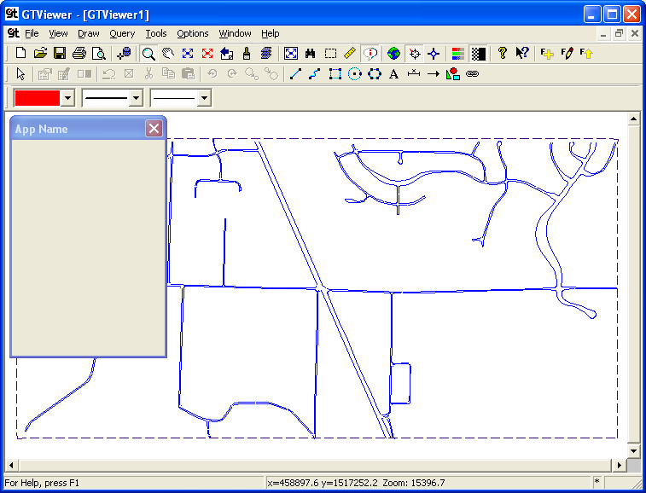
Once you have verified that the empty dialog comes up, you can exit GTViewer and proceed to the next step, Highlight by Phase Example Application in VB.NET (p. 24).

Creating an External Application for GTViewer with Visual Studio .NET 2008

- Create a new Windows project in Visual Studio. The project type can be either Visual Basic or C#. This example will be Visual Basic .NET. The .NET Framework can be set to 2.0, 3.0, or 3.5.
- Select the Windows Forms Control Library from the list of templates:
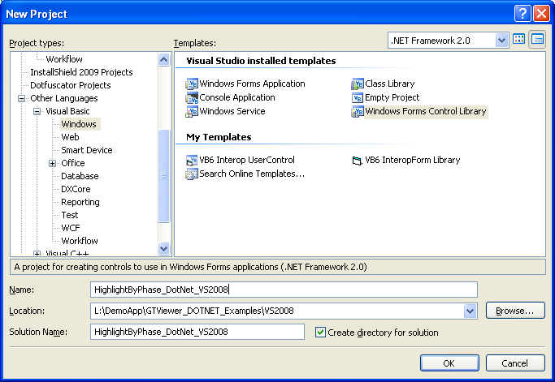

- The next step is to add GTViewer as a reference to your project so that the COM interface will be available to Intellisense and the GTViewer types will be defined. If you are using XP, this process is very simple. For Vista, the process is more complicated. Both XP and Vista instructions are provided below.
For XP
Once the Project is created, add the GTViewer.tlb as a reference. Select Project/Add Reference in Visual Studio:
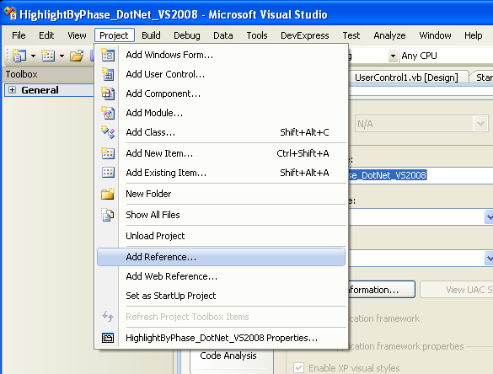
Browse to find the GTViewer.tlb file which will be located in the GTViewer product directory. This directory will be c:\Program Files\Graphic Technologies Inc\GTViewer (or something similar):
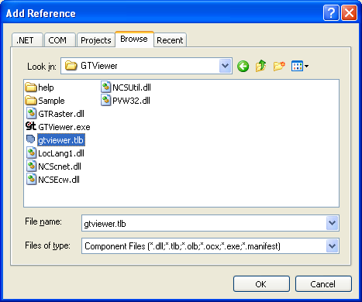
Then click OK.
For Vista
Security Issues prevent Visual Studio from automatically creating the COM wrapper dll. This problem is very likely a bug in Visual Studio working with Vista and may be resolved by Microsoft at some point in the future; however, the work around is straight forward.
With GTViewer version 8.0.0.15+, the COM Wrapper Dll is provided. It is called GTViewer.dll. Follow the XP instructions above for adding a reference, only select the GTViewer.dll instead of GTViewer.tlb.
If you are using a version of GTViewer that does not deliver the GTViewer.dll, you can create one yourself using the Tlbimp utility. You must run the Visual Studio Command Prompt (located under Programs/Visual Studio .NET 200X/Visual Studio Tools). You must run the command prompt as Administrator (right click and selected Run As Administrator). Then, in the new command prompt window, change the directory to the GTViewer product directory (c:\program files\graphic technologies inc\GTViewer). Run the tlbimp command with the following parameters:
tlbimp gtviewer.tlb /out:gtviewer.dll

- Several Project settings need to be made before creating the External Application. In Visual Studio, select Project/<Project Name> Properties, then:
- On the Application Tab, Click the Assembly Information button:
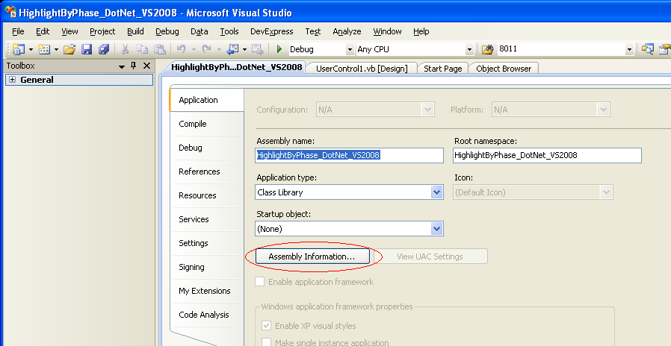

- Check the Make assembly COM-Visible box on the Assembly Information dialog:
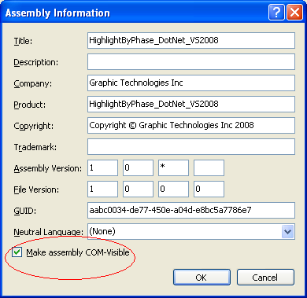
Then click OK.

- On the Compile Tab, set the Option Strict setting to On. Using Option Strict is optional; however, it is recommended, especially if you plan on using Dotfuscator or simply want more design-time checks to be performed on your code.

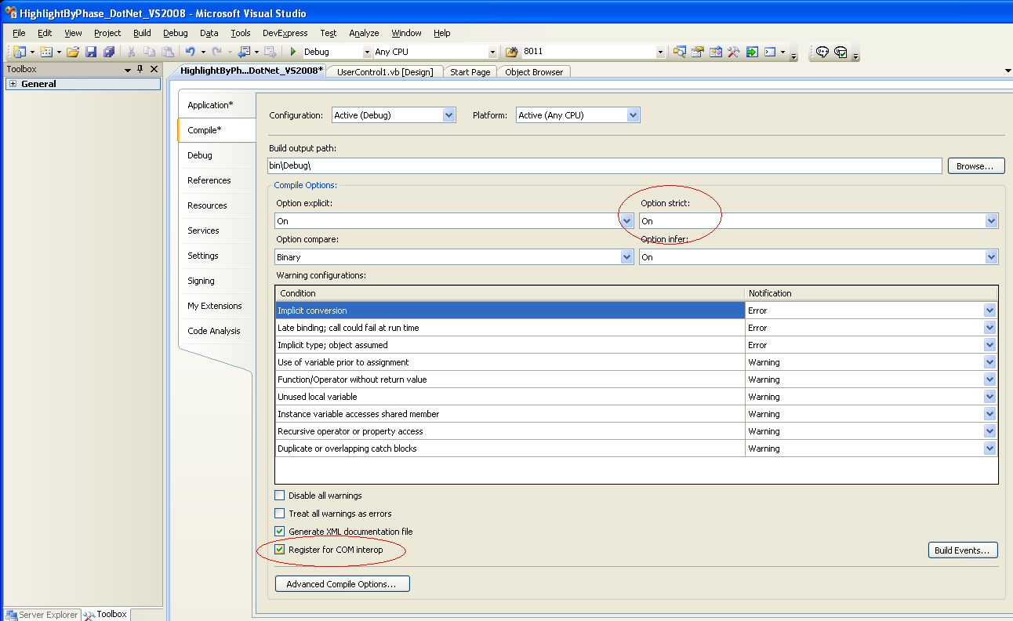
- Also on the Compile Tab, check the Register for COM interop box. If this option is not checked, you will have to manually register the application with Regasm.
- On the Debug Tab, change the Start Action to Start external program and browse to the GTViewer.exe in the GTViewer Product directory (which should be c:\program files\graphic technologies inc\gtviewer or similar):
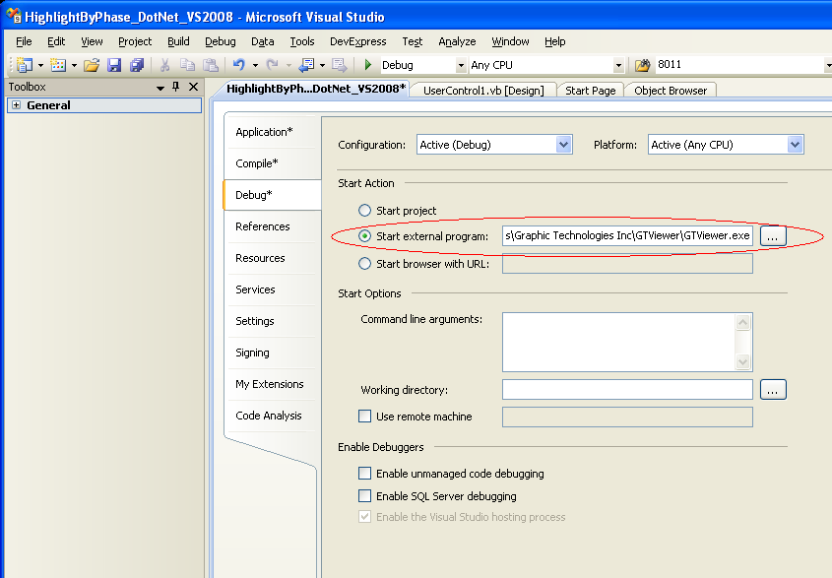

- In the Solution Explorer, right-click on the UserControl1.vb and choose View Designer:
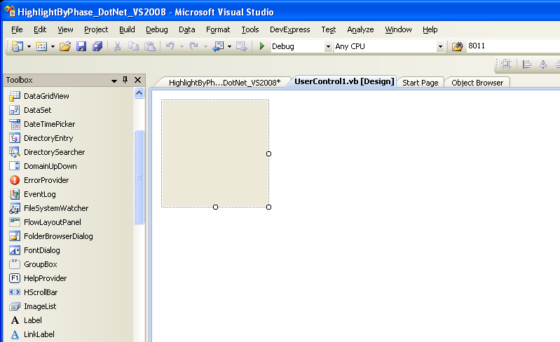
- Make the Control’s design surface larger. The size of the surface does not determine the size of the control in GTViewer.
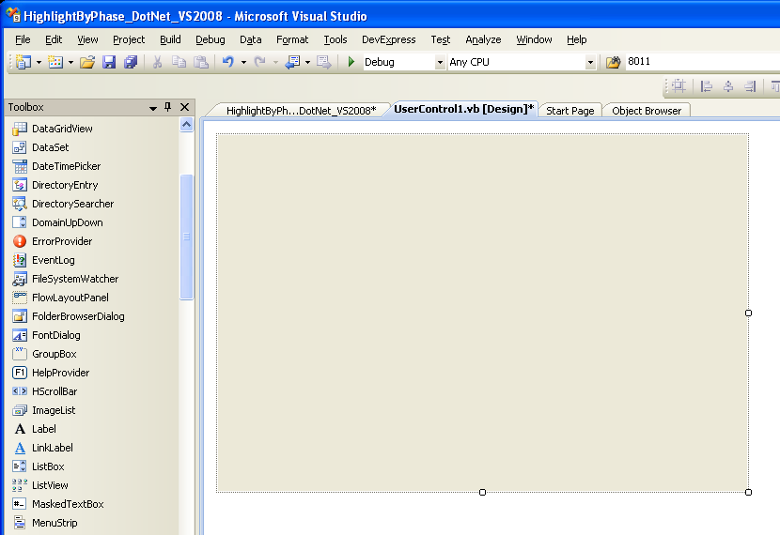

- Place a Panel control on the Control’s design surface. You will find Panel in the Toolbox under Containers. The Panel is used to size the control automatically when the External Application is displayed in GTViewer. There are many ways that this automatic sizing can be done; this simple approach is more than adequate for this example. The Panel should start at the upper left corner (0,0) and be the size that you want the application to appear in GTViewer. You will place all controls for the External Application in the panel. Make sure the panel is called Panel1 (or modify the AdjustDialogSize function in the code to match; AdjustDialogSize is discussed later).
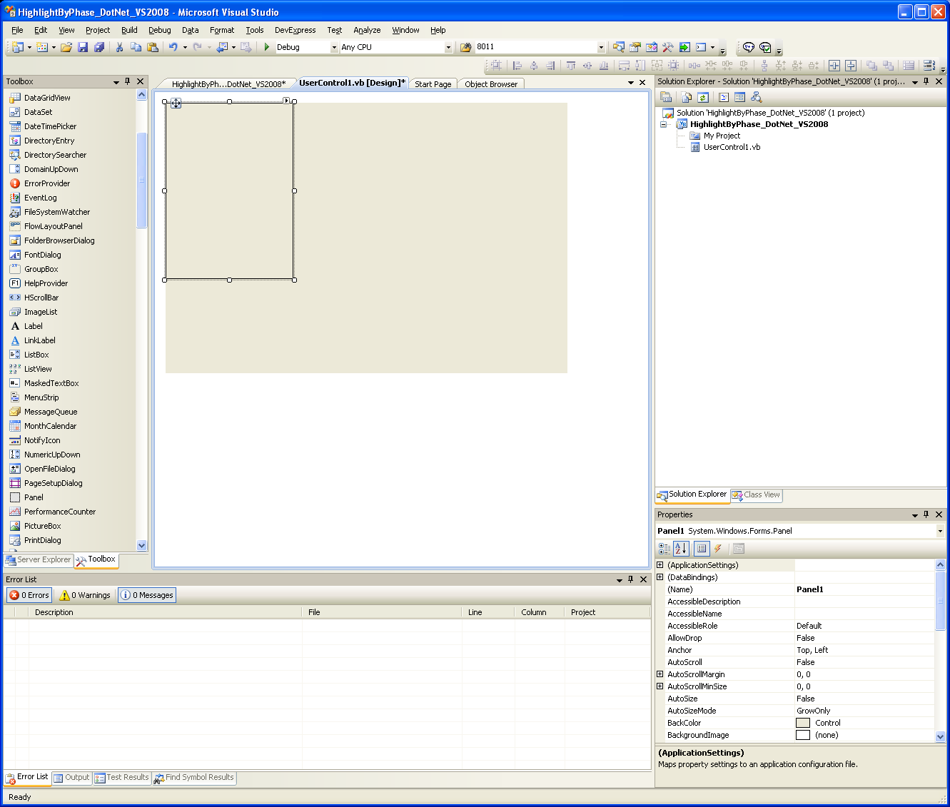
- In the Solution Explorer, right click on the UserControl1.vb file and select View Code. Then paste a copy of the following code template into the Control’s code page.
Imports System.Runtime.InteropServices

<ClassInterface(ClassInterfaceType.AutoDual)> _
Public Class UserControl1

Dim appObj As GTViewer.Application = Nothing
Dim docObj As GTViewer.Document = Nothing
Dim viewObj As GTViewer.View = Nothing
Dim dlgObj As GTViewer.DialogObject = Nothing

Public Sub SetApplicationObject(ByVal obj As Object)
appObj = CType(obj, GTViewer.Application)
End Sub

Public Sub SetDocumentObject(ByVal obj As Object)
docObj = CType(obj, GTViewer.Document)
End Sub

Public Sub SetViewObject(ByVal obj As Object)
viewObj = CType(obj, GTViewer.View)
End Sub

Public Sub SetDialogObject(ByVal obj As Object)
dlgObj = CType(obj, GTViewer.DialogObject)
End Sub

Public Sub EventMessage(ByVal messageType As Long, ByVal value1 As Long, _
ByVal value2 As Long, ByVal value3 As Long, _
ByVal value4 As Long)

Select Case messageType
Case 0
' Initialization Code here
dlgObj.SetTitle("App Name")
AdjustDialogSize()

Case 1
' Termination Code here

End Select

End Sub

Private Sub AdjustDialogSize()

Panel1.BorderStyle = Windows.Forms.BorderStyle.None

dlgObj.SetSizeEx(Panel1.Width + Panel1.Left + 6, _
Panel1.Height + Panel1.Top + 38, 0)

End Sub

End Class

The code shown above is the minimum code required to use an External Application with GTViewer. The template code is similar to the Visual Basic 6 External Application template code, but there are some differences. A detailed description of the code follows:
- The InteropServices assembly must be imported. Make sure the following line is at the top of the file:
Imports System.Runtime.InteropServices

You may have other assemblies to import, but this one is required.
- You must specify the Class Interface type for the User Control:
<ClassInterface(ClassInterfaceType.AutoDual)> _
Public Class UserControl1
.
.
.
End Class

If the Class Interface type is not specified like it is shown above, GTViewer will not see the User Control.
- Define global variables for the GTViewer interface objects:
Dim appObj As GTViewer.Application = Nothing
Dim docObj As GTViewer.Document = Nothing
Dim viewObj As GTViewer.View = Nothing
Dim dlgObj As GTViewer.DialogObject = Nothing

If the GTViewer.tlb file has not been set as a Project Reference, the GTViewer types will not be recognized.

- The Interface Object assignment methods must be provided:
Public Sub SetApplicationObject(ByVal obj As Object)
appObj = CType(obj, GTViewer.Application)
End Sub

Public Sub SetDocumentObject(ByVal obj As Object)
docObj = CType(obj, GTViewer.Document)
End Sub

Public Sub SetViewObject(ByVal obj As Object)
viewObj = CType(obj, GTViewer.View)
End Sub

Public Sub SetDialogObject(ByVal obj As Object)
dlgObj = CType(obj, GTViewer.DialogObject)
End Sub
These methods are exposed by the COM interface so that GTViewer can set the User Control’s global variables to the correct instances of the objects.
- The EventMessage method is exposed by the COM interface so that GTViewer can communicate with the User Control and relay event information:
Public Sub EventMessage(ByVal messageType As Long, ByVal value1 As Long,_
ByVal value2 As Long, ByVal value3 As Long, _
ByVal value4 As Long)

Select Case messageType
Case 0
' Initialization Code here
dlgObj.SetTitle("App Name")
AdjustDialogSize()

Case 1
' Termination Code here
End Select

End Sub
The GTVx.doc (which documents the API for GTViewer and GTVx) will describe all of the MessageTypes that can be sent to this method (under the GTViewer Event Message Types section). The template example contains only the 2 messages. Type 0 is always fired when the communication is established and the Control is ready to run. This event is typically used to change the title of the external application and to set the size of the Control’s dialog box (discussed next). Message Type 1 is fired when the document with which the User Control is associated is closing. If any persistent storage or cleanup needs to be performed, this is the place to do it.
- The AdjustDialogSize method is provided so that the size of the control is automatically communicated to GTViewer. In the past, the size of the control had to be defined in the .GTM file, but this simple method can now adjust the size automatically based on the Panel placed earlier in the Control’s design surface:
Private Sub AdjustDialogSize()

Panel1.BorderStyle = Windows.Forms.BorderStyle.None

dlgObj.SetSizeEx(Panel1.Width + Panel1.Left + 6, _
Panel1.Height + Panel1.Top + 38, 0)

End Sub

This Sub adjust the dialog generated by GTViewer to be the same size as Panel1. The 6 and 38 offsets account for the borders of the dialog itself.

The auto sizing capability is dependent on the Panel control placed on the form. The dialog adjusts to fit the panel. The border of the panel is turned off as well, so it will not be visible while the External Application is running.
9) The .GTM file used with your data must be modified to specify the External Applications you want made available to your data. In the [External Applications] section, add a DotNet entry in the following format:
DotNet=<name>|<menu Position>|<objectPath>|<mode>|<flags>|<height>|<width>|<x>|<y>|
- Name is the name that will appear on the Query menu in GTViewer at the bottom of the list after the names of locate and thematic highlight queries. The Name must be unique.

- Menu Position is for future use. Currently, it should be set to 1.

- ObjectPath is the path to the .NET user control that the system will recognize. The path will be the <Assembly name>.<UserControl name>.

- Mode is set to 0 for modal dialog and 1 for non-modal. Modal dialogs must complete before they return control to GTViewer; Non-modal dialogs can run simultaneously with GTViewer.

- Flags is for future use. Currently, it should be set to 0.

- Height is the height in pixels of the area that will be reserved in GTViewer for the display of the user control. The Height can also be specified as an asterisk (*) to indicate that the application will determine the Height.

- Width is the width in pixels of the area that will be reserved in GTViewer for the display of the user control. The Width can also be specified as an asterisk (*) to indicate that the application will determine the Width.

- X is horizontal position in the GTViewer map window at which the upper left hand corner of the user control will be displayed.
- Y is vertical position in the GTViewer map window at which the upper left hand corner of the user control will be displayed.

For the current example, this entry would be:
[External Applications]
DotNet=Highlight By Phase (VS 2008)|1|HighlightByPhase_DotNet_VS2008.UserControl1|2|0|*|*|0|0|

10) At this point, you can compile and run the application. The Debugger will start GTViewer, so make sure that GTViewer is not running before you start the External Application. Select Debug/Start Debugging (or press F5). GTViewer will be launched. You will then need to open your data (if open last file is not turned on). The new External Application should appear under GTViewer’s Query menu. When you select it, you will see the empty template dialog:

Once you have verified that the empty dialog comes up, you can exit GTViewer and proceed to the next step, Highlight by Phase Example Application in VB.NET (p. 24).

Highlight by Phase Example Application in VB.NET

- Now the rest of the Highlight by Phase example application can be implemented. All of the previous steps will be the same for any External Application. What happens from this point forward is specific to the External Application you are creating.

In the Panel, add a Group Box that contains 5 Check Boxes. Then add 2 Buttons:
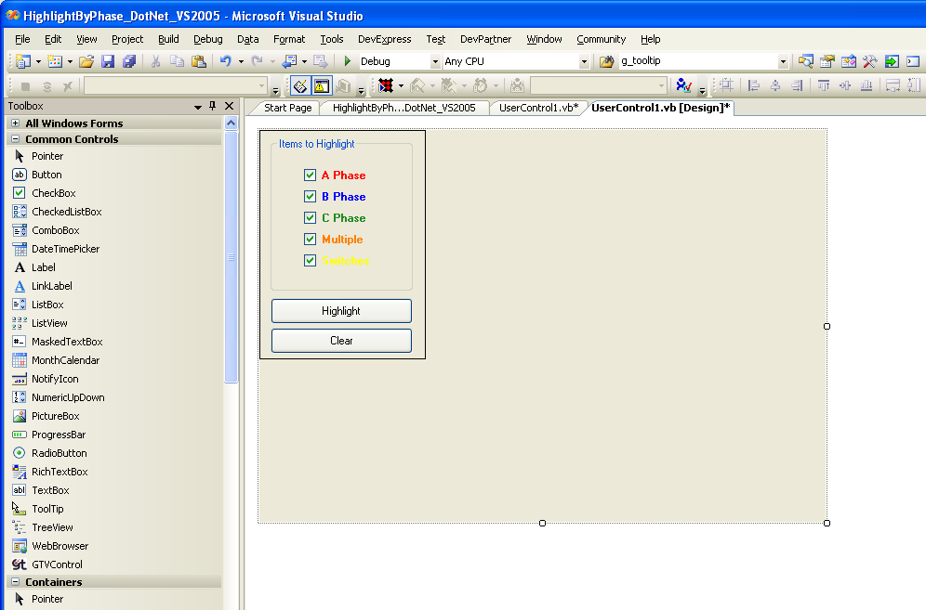
The CheckBoxes are named: CheckBoxA, CheckBoxB, CheckBoxC, CheckBoxMultiple, and CheckBoxSwitches.
The two buttons are named ButtonHighlight and ButtonClear.

- The complete code for the Highlight by Phase Example application is shown on the next few pages.

Complete Listing for Highlight by Phase Application

Imports System.Runtime.InteropServices

< ClassInterface(ClassInterfaceType.AutoDual)> _
Public Class UserControl1

Dim appObj As GTViewer.Application = Nothing
Dim docObj As GTViewer.Document = Nothing
Dim viewObj As GTViewer.View = Nothing
Dim dlgObj As GTViewer.DialogObject = Nothing

Const DATAID As Integer = 1
Dim g_connTableId As Integer = -1
Dim g_connPhasePos As Integer = -1

Dim RED_COLOR As Integer = RGB(255, 0, 0)
Dim GREEN_COLOR As Integer = RGB(0, 255, 0)
Dim ORANGE_COLOR As Integer = RGB(255, 128, 0)
Dim BLUE_COLOR As Integer = RGB(0, 0, 255)
Dim ERROR_COLOR As Integer = RGB(128, 0, 255)
Dim SWITCH_COLOR As Integer = RGB(255, 255, 0)

Dim g_lastGidLookup As Integer = 0
Dim g_lastUfidLookup As Integer = 0
Dim g_lastDrawType As Integer = 0

Const MAX_CIRCLES As Integer = 1000

Class CircleItem
Public Sub New(ByVal categoryId As Integer, ByVal offset As Integer)
m_categoryId = categoryId
m_offset = offset
End Sub

Public m_categoryId As Integer
Public m_offset As Integer
End Class

Dim g_circleList As New Generic.List(Of CircleItem)

Public Sub SetApplicationObject(ByVal obj As Object)
appObj = CType(obj, GTViewer.Application)
End Sub

Public Sub SetDocumentObject(ByVal obj As Object)
docObj = CType(obj, GTViewer.Document)
End Sub

Public Sub SetViewObject(ByVal obj As Object)
viewObj = CType(obj, GTViewer.View)
End Sub

Public Sub SetDialogObject(ByVal obj As Object)
dlgObj = CType(obj, GTViewer.DialogObject)
End Sub

Public Sub EventMessage(ByVal messageType As Long, ByVal value1 As Long, _
ByVal value2 As Long, ByVal value3 As Long, _
ByVal value4 As Long)

'ListBox1.Items.Add("Message: " + messageType.ToString)

Select Case messageType
Case 0
' Initialization code here
dlgObj.SetTitle("Highlight by Phase")
AdjustDialogSize()
Case 1
' Termination code here

End Select

End Sub

Private Sub AdjustDialogSize()

Panel1.BorderStyle = Windows.Forms.BorderStyle.None

dlgObj.SetSizeEx(Panel1.Width + Panel1.Left + 6, _
Panel1.Height + Panel1.Top + 38, 0)

End Sub

Private Function InitializeTableInfo() As Boolean

g_connTableId = docObj.DataGetTableId(DATAID, "CONNECTIVITY")

g_connPhasePos = docObj.DataGetTableAttrPos(DATAID, g_connTableId, "PH")

g_lastGidLookup = -1
g_lastUfidLookup = -1
g_lastDrawType = 0

If g_connTableId = -1 Or g_connPhasePos = -1 Then

MessageBox.Show("Unable to Initialize Connectivity Table Query")
Return False

End If

Return True

End Function

Private Sub ButtonHighlight_Click(ByVal sender As System.Object, _
ByVal e As System.EventArgs) Handles ButtonHighlight.Click

If Not InitializeTableInfo() Then
Return
End If

g_circleList.Clear()

Dim oldWeight As Integer = docObj.GetCurrentWeight

docObj.SetCurrentWeight(4)

Cursor = Cursors.WaitCursor

Dim xlow As Double
Dim ylow As Double
Dim xhigh As Double
Dim yhigh As Double

If viewObj.GetViewExtents(0, xlow, ylow, xhigh, yhigh) Then

Dim catList As Object = Nothing
Dim offsetList As Object = Nothing
Dim filterList As Object = Nothing
Dim itemCount As Integer = 0
Dim blockCount As Integer = 0

Dim filterStr As String

filterStr = "3:5, 3:8, 3:11, 3:10, 3:9, 3:7, 3:3, 3:2, 3:13, 3:14, 4:40, 4:39, 4:42, 4:41, 4:53, 4:54, 4:55, 4:5, 4:4, 4:12, 4:13, 4:20, 4:21, 4:26, 4:27, 4:51, 4:52, 4:33, 4:32, 4:47, 4:46, 4:15, 4:16, 4:23, 4:24, 4:29, 4:30, 4:35, 4:59, 4:57, 4:37"

itemCount = viewObj.GetElementsInRangeInitialize(0, _
xlow, ylow, xhigh, yhigh, 0, filterStr)

While viewObj.GetElementsInRangeFetch(1000, catList, offsetList, _
filterList, blockCount)

Dim cList() As Object = CType(catList, Object())
Dim oList() As Object = CType(offsetList, Object())
Dim fList() As Object = CType(filterList, Object())

For j As Integer = 0 To blockCount - 1
ProcessFeature(CInt(cList(j)), CInt(oList(j)), CInt(fList(j)))
Next

catList = Nothing
offsetList = Nothing
filterList = Nothing

End While

viewObj.GetElementsInRangeReset()

End If

' draw circles for open points and switches

For i As Integer = 0 To g_circleList.Count - 1

DrawSwitch(g_circleList(i))

Next

viewObj.SetEmphasizeSessionGraphics(1)

viewObj.RefreshView()

Cursor = Cursors.Default

docObj.SetCurrentWeight(oldWeight)

End Sub

Sub DisplayItemResults(ByVal catId As Integer, ByVal offset As Integer, _
ByVal drawType As Integer)

Dim col As Integer
Dim weight As Integer

Select Case drawType

Case 1
col = ORANGE_COLOR
weight = 4
Case 2
col = RED_COLOR
weight = 2
Case 3
col = BLUE_COLOR
weight = 2
Case 4
col = GREEN_COLOR
weight = 2
Case Else

col = ERROR_COLOR
weight = 1

End Select

If drawType <> -1 Then
viewObj.HighlightAddElementEx(catId, offset, col, weight, 0, 0, 10, 1)
End If

End Sub

Function GetPhaseInfo(ByVal gid As Integer, ByVal ufid As Integer, _
ByVal filterid As Integer, ByRef drawType As Integer) As Boolean

Dim phs As String

If g_lastGidLookup = gid And g_lastUfidLookup = ufid Then
drawType = g_lastDrawType
Return True
End If

If docObj.DataInitializeFetch(DATAID, g_connTableId, gid, ufid) Then

Dim tableId As Integer
Dim count As Integer
Dim valueList As Object = Nothing

While docObj.DataFetchRecord(tableId, valueList, count) And count < 100

Dim vList() As Object = CType(valueList, Object())

phs = vList(g_connPhasePos).ToString.ToUpper.Trim

ProcessItem(phs, gid, ufid, filterid, drawType)

g_lastGidLookup = gid
g_lastUfidLookup = ufid
g_lastDrawType = drawType

valueList = Nothing

End While

Return True

End If

Return False

End Function

Sub DrawSwitch(ByVal item As CircleItem)

Dim xlow As Double
Dim ylow As Double
Dim xhigh As Double
Dim yhigh As Double

If docObj.GetElementRange(item.m_categoryId, item.m_offset, 0, _
xlow, ylow, xhigh, yhigh) Then

Dim cenx As Double
Dim ceny As Double

cenx = ((xhigh - xlow) / 2.0#) + xlow
ceny = ((yhigh - ylow) / 2.0#) + ylow

viewObj.HighlightAddCircle(0, cenx, ceny, 40000, SWITCH_COLOR, 0, 2000)
viewObj.HighlightAddCircle(0, cenx, ceny, 65000, SWITCH_COLOR, 2000, 5000)
viewObj.HighlightAddCircle(0, cenx, ceny, 100000, SWITCH_COLOR, 5000, 8000)
viewObj.HighlightAddCircle(0, cenx, ceny, 130000, SWITCH_COLOR, 8000, 10000)
viewObj.HighlightAddCircle(0, cenx, ceny, 165000, SWITCH_COLOR, 10000, 15000)
viewObj.HighlightAddCircle(0, cenx, ceny, 200000, SWITCH_COLOR, 15000, 20000)
viewObj.HighlightAddCircle(0, cenx, ceny, 250000, SWITCH_COLOR, 20000, 30000)
viewObj.HighlightAddCircle(0, cenx, ceny, 350000, SWITCH_COLOR, 30000, 60000)
viewObj.HighlightAddCircle(0, cenx, ceny, 500000, SWITCH_COLOR, 60000, 100000)
viewObj.HighlightAddCircle(0, cenx, ceny, 750000, SWITCH_COLOR, 100000, 0)

End If

End Sub

Sub ProcessItem(ByVal phs As String, ByVal gid As Integer, ByVal ufid As Integer, _
ByVal filterid As Integer, ByRef drawType As Integer)

Dim count As Integer = 0
Dim aFlag As Boolean = False
Dim bFlag As Boolean = False
Dim cFlag As Boolean = False
Dim multiFlag As Boolean = False

If InStr(phs, "A") <> 0 Then
aFlag = True
count = count + 1
End If

If InStr(phs, "B") <> 0 Then
bFlag = True
count = count + 1
End If

If InStr(phs, "C") <> 0 Then
cFlag = True
count = count + 1
End If

If count > 1 Then
multiFlag = True
aFlag = False
bFlag = False
cFlag = False
End If

drawType = -1

If multiFlag And CheckBoxMultiple.Checked Then
drawType = 1
ElseIf aFlag And CheckBoxA.Checked Then
drawType = 2
ElseIf bFlag And CheckBoxB.Checked Then
drawType = 3
ElseIf cFlag And CheckBoxC.Checked Then
drawType = 4
End If

End Sub

Sub ProcessFeature(ByVal catId As Integer, ByVal offset As Integer, _
ByVal filterid As Integer)

Dim drawType As Integer = -1

Dim linkageList As Object = Nothing
Dim linkCount As Integer

Dim gid As Integer
Dim ufid As Integer

If docObj.GetElementLinkage(catId, offset, linkageList, linkCount) Then

If linkCount > 1 Then

Dim lList() As Object = CType(linkageList, Object())

gid = Convert.ToInt32(lList(0))
ufid = Convert.ToInt32(lList(1))

End If

GetPhaseInfo(gid, ufid, filterid, drawType)

If CheckBoxSwitches.Checked Then
CheckForSwitch(catId, offset, gid, ufid, filterid)
End If

DisplayItemResults(catId, offset, drawType)

End If

End Sub

Private Sub ButtonClear_Click(ByVal sender As System.Object, _
ByVal e As System.EventArgs) Handles ButtonClear.Click

g_circleList.Clear()

viewObj.HighlightReset()

viewObj.SetEmphasizeSessionGraphics(0)

viewObj.RefreshView()

End Sub

Private Sub CheckForSwitch(ByVal catId As Integer, ByVal offset As Integer, _
ByVal gid As Integer, ByVal ufid As Integer, ByVal filterId As Integer)

If catId = 4 And filterId = 13 Then

g_circleList.Add(New CircleItem(catId, offset))

End If

End Sub

End Class

3) The Highlight by Phase application is for use with the Sample data that is delivered with GTViewer. It can, however, be modified to work with any electric data.

Moving from Visual Basic 6 to Visual Basic .NET
If you are a VB6 programmer and are moving to VB.NET, there are a few differences that should be pointed out in the code.
1) The .NET Interface to GTViewer wants Integers instead of Long values. While a Long will work, it will give a warning until you change it to an Integer.

2) There is no Variant Type in VB.NET. VB6 would only work with Variants for complex types in the COM interface, and GTViewer’s interface is for COM
For most of GTViewer’s methods, standard types are used and there is little difference between calling them in VB6 and VB.NET:
Dim xlow As Double
Dim ylow As Double
Dim xhigh As Double
Dim yhigh As Double

If viewObj.GetViewExtents(0, xlow, ylow, xhigh, yhigh) Then
.
.
.
End If

However, if you are returning a list of values, then there is a difference since Variants are not supported in VB.NET. The solution is to use the Object type instead.
If docObj.DataInitializeFetch(DATAID, g_connTableId, gid, ufid) Then

Dim tableId As Integer
Dim count As Integer
Dim valueList As Object = Nothing

While docObj.DataFetchRecord(tableId, valueList, count) And count < 100

Dim vList() As Object = CType(valueList, Object())

phs = vList(g_connPhasePos).ToString.ToUpper.Trim

ProcessItem(phs, gid, ufid, filterid, drawType)

g_lastGidLookup = gid
g_lastUfidLookup = ufid
g_lastDrawType = drawType

valueList = Nothing

End While

The DataFetchRecord method in the above code segment returns the list of values as a Variant Array. So, valueList is defined as an Object. The object will return the variant array; however, it must be appropriately cast back to a type that is usable in .NET. This problem is complicated further when the Option Strict On is used as it disallows late binding.
Immediately after the call to DataFetchRecord, a new variable called vList is declared as an array of Objects and the valueList variable is cast to an array of Objects. For VB6, an array had to be returned as a Variant Array of Variants, so both levels of this abstraction have to be explicitly resolved to get through the Option Strict On requirements. The individual elements in the vlist array can then be explicitly converted to the appropriate type (which is a string in this example).

3) One additional item that is required in this example is that the valueList must be set to Nothing before the DataFetchRecord can be called again with the same variable. The COM method that GTViewer exposed cannot clear the .NET generated object variable, but setting the variable to Nothing resolves this issue. If you do not set the variable back to Nothing, you will have a Type Mismatch runtime error. This will be true for any method returning a variant, so always set them to Nothing when finished using them if the variable is going to be used again.

External Application Template Code in C#
using System;
using System.Collections.Generic;
using System.ComponentModel;
using System.Drawing;
using System.Data;
using System.Text;
using System.Windows.Forms;
using System.Runtime.InteropServices;

namespace HighlightByPhase_CSharp_VS2005
{
[ClassInterface(ClassInterfaceType.AutoDual)]
public partial class UserControl1 : UserControl
{
GTViewer.Application appObj = null;
GTViewer.Document docObj = null;
GTViewer.View viewObj = null;
GTViewer.DialogObject dlgObj = null;

public UserControl1()
{
InitializeComponent();
}

public void SetApplicationObject(object obj)
{
appObj = (GTViewer.Application)obj;
}

public void SetDocumentObject(object obj)
{
docObj = (GTViewer.Document)obj;
}

public void SetViewObject(object obj)
{
viewObj = (GTViewer.View)obj;
}

public void SetDialogObject(object obj)
{
dlgObj = (GTViewer.DialogObject)obj;
}

public void EventMessage(long messageType, long value1, long value2,
long value3, long value4)
{
switch (messageType)
{
case 0:
// Initialization Code here
dlgObj.SetTitle("App Name");
AdjustDialogSize();
break;

case 1:
// Termination Code here
break;
}
}

private void AdjustDialogSize()
{
panel1.BorderStyle = BorderStyle.None;

dlgObj.SetSizeEx(panel1.Width + panel1.Left + 6, panel1.Height + panel1.Top + 38, 0);
}
}
}

Highlight by Phase Application in C#
using System;
using System.Collections.Generic;
using System.ComponentModel;
using System.Drawing;
using System.Data;
using System.Text;
using System.Windows.Forms;
using System.Runtime.InteropServices;

namespace HighlightByPhase_CSharp_VS2005
{

[ClassInterface(ClassInterfaceType.AutoDual)]
public partial class UserControl1 : UserControl
{
GTViewer.Application appObj = null;
GTViewer.Document docObj = null;
GTViewer.View viewObj = null;
GTViewer.DialogObject dlgObj = null;

const int DATAID = 1;
int g_connTableId = -1;
int g_connPhasePos = -1;

int RED_COLOR = 0x0000FF;
int GREEN_COLOR = 0x00FF00;
int ORANGE_COLOR = 0x0080FF;
int BLUE_COLOR = 0xFF0000;
int ERROR_COLOR = 0xFF0080;
int SWITCH_COLOR = 0x00FFFF;

int g_lastGidLookup = 0;
int g_lastUfidLookup = 0;
int g_lastDrawType = 0;

const int MAX_CIRCLES = 1000;

public class CircleItem
{
public CircleItem(int categoryId, int offset)
{
m_categoryId = categoryId;
m_offset = offset;
}

public int m_categoryId;
public int m_offset;
}

System.Collections.Generic.List<CircleItem> g_circleList = new System.Collections.Generic.List<CircleItem>();

public UserControl1()
{
InitializeComponent();
}

public void SetApplicationObject(object obj)
{
appObj = (GTViewer.Application)obj;
}

public void SetDocumentObject(object obj)
{
docObj = (GTViewer.Document)obj;
}

public void SetViewObject(object obj)
{
viewObj = (GTViewer.View)obj;
}

public void SetDialogObject(object obj)
{
dlgObj = (GTViewer.DialogObject)obj;
}

public void EventMessage(long messageType, long value1, long value2, long value3, long value4)
{
switch (messageType)
{
case 0:
// Initialization Code here
dlgObj.SetTitle("Highlight by Phase (C#)");
AdjustDialogSize();
break;

case 1:
// Termination Code here
break;
}
}

private void AdjustDialogSize()
{
Panel1.BorderStyle = BorderStyle.None;

dlgObj.SetSizeEx(Panel1.Width + Panel1.Left + 6, Panel1.Height + Panel1.Top + 38, 0);
}

private bool InitializeTableInfo()
{
g_connTableId = docObj.DataGetTableId(DATAID, "CONNECTIVITY");

g_connPhasePos = docObj.DataGetTableAttrPos(DATAID, g_connTableId, "PH");

g_lastGidLookup = -1;
g_lastUfidLookup = -1;
g_lastDrawType = 0;

if (g_connTableId == -1 | g_connPhasePos == -1)
{
MessageBox.Show("Unable to Initialize Connectivity Table Query");
return false;
}

return true;
}

private void ButtonHighlight_Click(object sender, EventArgs e)
{
if (!InitializeTableInfo()) return;

g_circleList.Clear();

int oldWeight = docObj.GetCurrentWeight();

docObj.SetCurrentWeight(4);

Cursor = Cursors.WaitCursor;

double xlow = 0;
double ylow = 0;
double xhigh = 0;
double yhigh = 0;

if (viewObj.GetViewExtents(0, ref xlow, ref ylow, ref xhigh, ref yhigh))
{
object catList = null;
object offsetList = null;
object filterList = null;
int itemCount = 0;
int blockCount = 0;

string filterStr = null;

filterStr = "3:5, 3:8, 3:11, 3:10, 3:9, 3:7, 3:3, 3:2, 3:13, 3:14, 4:40, 4:39, 4:42, 4:41, 4:53, 4:54, 4:55, 4:5, 4:4, 4:12, 4:13, 4:20, 4:21, 4:26, 4:27, 4:51, 4:52, 4:33, 4:32, 4:47, 4:46, 4:15, 4:16, 4:23, 4:24, 4:29, 4:30, 4:35, 4:59, 4:57, 4:37";

itemCount = viewObj.GetElementsInRangeInitialize(0, xlow, ylow, xhigh, yhigh, 0, filterStr);

while (viewObj.GetElementsInRangeFetch(1000, ref catList, ref offsetList, ref filterList, ref blockCount))
{
object[] cList = (object[])catList;
object[] oList = (object[])offsetList;
object[] fList = (object[])filterList;

for (int j = 0; j <= blockCount - 1; j++)
{
ProcessFeature((int)cList[j], (int)oList[j], (int)fList[j]);
}

catList = null;
offsetList = null;
filterList = null;
}
viewObj.GetElementsInRangeReset();
}

// draw circles for open points and switches

for (int i = 0; i <= g_circleList.Count - 1; i++)
{
DrawSwitch(g_circleList[i]);
}

viewObj.SetEmphasizeSessionGraphics(1);

viewObj.RefreshView();

Cursor = Cursors.Default;

docObj.SetCurrentWeight(oldWeight);
}

public void DisplayItemResults(int catId, int offset, int drawType)
{

int col = 0;
int weight = 0;

switch (drawType)
{
case 1:
col = ORANGE_COLOR;
weight = 4;
break;
case 2:
col = RED_COLOR;
weight = 2;
break;
case 3:
col = BLUE_COLOR;
weight = 2;
break;
case 4:
col = GREEN_COLOR;
weight = 2;
break;

default:
col = ERROR_COLOR;
weight = 1;
break;
}

if (drawType != -1)
{
viewObj.HighlightAddElementEx(catId, offset, col, weight, 0, 0, 10, 1);
}
}

public bool GetPhaseInfo(int gid, int ufid, int filterid, ref int drawType)
{
string phs = null;

if (g_lastGidLookup == gid & g_lastUfidLookup == ufid)
{
drawType = g_lastDrawType;
return true;
}

if (docObj.DataInitializeFetch(DATAID, g_connTableId, gid, ufid))
{
int tableId = 0;
int count = 0;
object valueList = null;

while (docObj.DataFetchRecord(ref tableId, ref valueList, ref count) & count < 100)
{
object[] vList = (object[])valueList;

phs = vList[g_connPhasePos].ToString().ToUpper().Trim();

ProcessItem(phs, gid, ufid, filterid, ref drawType);

g_lastGidLookup = gid;
g_lastUfidLookup = ufid;
g_lastDrawType = drawType;

valueList = null;
}
return true;
}
return false;
}

public void DrawSwitch(CircleItem item)
{
double xlow = 0;
double ylow = 0;
double xhigh = 0;
double yhigh = 0;

if (docObj.GetElementRange(item.m_categoryId, item.m_offset, 0, ref xlow, ref ylow, ref xhigh, ref yhigh))
{
double cenx = 0;
double ceny = 0;

cenx = ((xhigh - xlow) / 2.0) + xlow;
ceny = ((yhigh - ylow) / 2.0) + ylow;

viewObj.HighlightAddCircle(0, cenx, ceny, 40000, SWITCH_COLOR, 0, 2000);
viewObj.HighlightAddCircle(0, cenx, ceny, 65000, SWITCH_COLOR, 2000, 5000);
viewObj.HighlightAddCircle(0, cenx, ceny, 100000, SWITCH_COLOR, 5000, 8000);
viewObj.HighlightAddCircle(0, cenx, ceny, 130000, SWITCH_COLOR, 8000, 10000);
viewObj.HighlightAddCircle(0, cenx, ceny, 165000, SWITCH_COLOR, 10000, 15000);
viewObj.HighlightAddCircle(0, cenx, ceny, 200000, SWITCH_COLOR, 15000, 20000);
viewObj.HighlightAddCircle(0, cenx, ceny, 250000, SWITCH_COLOR, 20000, 30000);
viewObj.HighlightAddCircle(0, cenx, ceny, 350000, SWITCH_COLOR, 30000, 60000);
viewObj.HighlightAddCircle(0, cenx, ceny, 500000, SWITCH_COLOR, 60000, 100000);
viewObj.HighlightAddCircle(0, cenx, ceny, 750000, SWITCH_COLOR, 100000, 0);
}
}

public void ProcessItem(string phs, int gid, int ufid, int filterid, ref int drawType)
{
int count = 0;
bool aFlag = false;
bool bFlag = false;
bool cFlag = false;
bool multiFlag = false;

if (phs.IndexOf("A") != -1)
{
aFlag = true;
count = count + 1;
}

if (phs.IndexOf("B") != -1)
{
bFlag = true;
count = count + 1;
}

if (phs.IndexOf("C") != -1)
{
cFlag = true;
count = count + 1;
}

if (count > 1)
{
multiFlag = true;
aFlag = false;
bFlag = false;
cFlag = false;
}

drawType = -1;

if (multiFlag & CheckBoxMultiple.Checked)
{
drawType = 1;
}
else if (aFlag & CheckBoxA.Checked)
{
drawType = 2;
}
else if (bFlag & CheckBoxB.Checked)
{
drawType = 3;
}
else if (cFlag & CheckBoxC.Checked)
{
drawType = 4;
}
}

public void ProcessFeature(int catId, int offset, int filterid)
{
int drawType = -1;

object linkageList = null;
int linkCount = 0;

int gid = 0;
int ufid = 0;

if (docObj.GetElementLinkage(catId, offset, ref linkageList, ref linkCount))
{
if (linkCount > 1)
{
object[] lList = (object[])linkageList;

gid = Convert.ToInt32(lList[0]);
ufid = Convert.ToInt32(lList[1]);
}

GetPhaseInfo(gid, ufid, filterid, ref drawType);

if (CheckBoxSwitches.Checked)
{
CheckForSwitch(catId, offset, gid, ufid, filterid);
}

DisplayItemResults(catId, offset, drawType);
}
}

private void ButtonClear_Click(object sender, EventArgs e)
{
g_circleList.Clear();

viewObj.HighlightReset();

viewObj.SetEmphasizeSessionGraphics(0);

viewObj.RefreshView();
}

private void CheckForSwitch(int catId, int offset, int gid, int ufid, int filterId)
{
if (catId == 4 & filterId == 13)
{
g_circleList.Add(new CircleItem(catId, offset));
}
}
}
}

